FINAL PROJECT DOCUMENTATION PAPER

A WEB-BASED VIA ONLINE STORE SYSTEM
Submitted by: Eljie J. Peteros
Course/Subject:BSIT 3A
Instructor: Jeremiah Dela Cruz
Date Submitted: May 22, 2026

TABLE OF CONTENTS
- Introduction
- Objectives of the System
- Scope and Limitations
- System Description
- Technologies Used
- System Design
- Database Structure
- Implementation and Testing
- Conclusion
- Recommendations
- References

CHAPTER 1: INTRODUCTION

1.1 Background of the Study
The rapid advancement of information and communication technology has dramatically transformed the way businesses operate in the modern world. The emergence of the internet as a global platform has paved the way for electronic commerce, commonly known as e-commerce, which has revolutionized traditional business models by allowing buyers and sellers to conduct transactions online without the constraints of physical location or business hours. Today, millions of businesses around the world rely on online platforms to reach a wider customer base, increase their revenue, and improve overall operational efficiency.
In the Philippines, the e-commerce industry has experienced unprecedented growth in recent years, particularly accelerated by shifting market dynamics that forced retail spaces to adapt their operations onto localized digital environments. Filipino consumers have increasingly embraced online shopping as an indispensable, permanent alternative to in-person purchasing. This shift has created a significant demand for specialized web-based store systems that are secure, highly performant, and capable of maintaining clean transactional logic across different ordering paths.
Despite the growing popularity of online shopping, small-to-medium enterprises (SMEs) in the apparel sector frequently struggle to manage their backend operations smoothly. When moving away from social media message-based transactions toward independent web applications, systems often suffer from inventory inconsistencies and disjointed data records. This project, titled A Web-Based Via Online Store System, was developed to address these operational inefficiencies by providing a precise, unified application layer that synchronizes customer purchasing mechanisms with direct admin-level management controls.

1.2 Purpose of the System
The primary purpose of A Web-Based Via Online Store System is to deliver a reliable, centralized web environment that automates inventory tracking, secures user sessions, and optimizes checkout operations. The system aims to eliminate the limitations of manual tracking by binding storefront stock availability directly to automated server-side framework routines.
For the customer, the platform provides an intuitive storefront interface featuring an independent "Buy Now" option alongside a persistent multi-item shopping cart. For the administrator, the system provides an end-to-end management dashboard to handle product parameters, update fulfillment states, and maintain clean auditing records of store operational expenditures from a single backend control panel.

1.3 Importance of the Project
The development of this system holds significant importance for several target groups:
- For Business Owners: The system provides an integrated platform that connects sales data directly with an operational expense tracker, removing the need for auxiliary bookkeeping software and preventing stock discrepancies.
- For Customers: It delivers a dependable shopping experience where selected items remain securely tied to their accounts across browsing sessions without structural checkout bugs resetting their shopping cart data.
- For the Academic Community: This project demonstrates a robust implementation of modern PHP paradigms using Laravel, showing how web routing, relational Object-Relational Mapping (ORM), and session middleware combine to secure an application.

1.4 Problems the System Aims to Solve
- Cart Synchronization During Direct Checkout: Resolving a frequent e-commerce flaw where triggering an isolated single-item "Buy Now" checkout accidentally purges or corrupts unrelated items already sitting within a user's persistent digital shopping cart.
- Inventory Drift and Concurrency Errors: Preventing differences between published stock listings and physical quantities by locking queries within isolated database transactions during checkouts.
- Disjointed Operational Visibility: Replacing fragmented management models with a unified administrative panel that binds incoming customer order states directly to inventory deduction loops and cost-of-goods expense sheets.
- Unstable Mailer Infrastructure over Cloud DNS: Correcting network layer routing drops (ENETUNREACH) common during remote server interaction with external mail transfer networks by structuring explicit web environment configurations.

CHAPTER 2: OBJECTIVES OF THE SYSTEM

2.1 General Objective
The general objective of this project is to design, develop, and implement A Web-Based Via Online Store System using the structured Laravel PHP Framework, Eloquent ORM, and a MySQL relational database. The system provides role-isolated workflows for Customers and Administrators while guaranteeing atomic data reliability across all transaction points.

2.2 Specific Objectives
- To implement an advanced checkout state parser inside Laravel Controllers capable of safely distinguishing and isolating regular cart checkouts from immediate single-item "Buy Now" orders.
- To secure user route tracking by building independent server-side custom Laravel Middleware blocks that validate authentication states and enforce strict customer/admin permission walls.
- To build an atomic transactional database layer utilizing Laravel's database transaction facades (DB::transaction) that completely rolls back partial operations if stock numbers fail to fulfill checkout requirements.
- To mitigate hosting connectivity friction by tuning mail transport environment configurations within the framework to prevent SMTP execution dropouts during verification loops.
- To design an integrated tracking ledger inside the administrative dashboard that subtracts business expenses from real-time sales revenue using Eloquent aggregations to display precise net profitability margins.

CHAPTER 3: SCOPE AND LIMITATIONS

3.1 Scope of the System
The application limits its operational context to two explicit authentication roles: Customer and Administrator.

Customer Features:
- Secure authentication via standard encrypted passwords (using Laravel's native Hashing system) or verified third-party Google OAuth2 session parameters.
- Persistent data-driven shopping cart state tied to user identities within database records using Eloquent relationships rather than temporary browser cookies.
- Dual checkout mechanics allowing both bulk cart checkout and single-item direct ordering.
- Historical order panel tracking real-time status updates (e.g., Pending, Processing, Shipped, Completed) alongside user profile management.

Administrator Features:
- Dynamic data metrics dashboard compiling total customers, active orders, and real-time stock status summaries.
- Full CRUD capability over store products, pricing details, category groupings, and visual image paths.
- Live order processing tracking to update customer package delivery pipelines.
- Complete expense account ledgering to capture real-time operational costs.

Automated Functions:
- Server-side tracking of user last_seen timestamps upon verified web or API interactions.
- Asynchronous token dispatch systems powered by Laravel's built-in Mail services.

3.2 Limitations of the System
- No External Live Payment Settlement APIs: Payment operations (Cash/GCash) rely on simulated transaction confirmation parameters logged and confirmed directly via administrative interfaces rather than running active payment provider API webhooks.
- No Real-Time Third-Party Carrier Sync: Shipping logistics, location metrics, and courier rates utilize fixed calculation parameters managed directly within the store settings rather than calling out to live commercial shipping platforms.
- Strict Single-Vendor Context: The application design functions entirely as a single-merchant environment and does not support multi-tenant or third-party seller marketplace storefront models.
- Persistent Connection Dependency: The underlying application relies entirely on an active remote database pooling connection layer, meaning it cannot run transactions offline or cache mutations via local database syncing.

CHAPTER 4: SYSTEM DESCRIPTION

4.1 Overview of the System
A Web-Based Via Online Store System is built on a model-view-controller (MVC) architecture using Laravel. It processes HTTP layout rendering directly through Blade template views while managing operational transactions through secure Controller routing layers.
The frontend layout structures combine native HTML5/CSS3 styling with Bootstrap components. Security boundaries are strictly server-side, driven by Laravel's application middleware checking user permissions before serving private layout schemas.

4.2 Major Modules and Features
- Authentication & Guard Management Module: Leverages Laravel's native session-guard mechanics to manage local user states alongside third-party token bridges (Google OAuth2).
- Storefront Catalog and Query Filter Engine: Renders backend inventory items and processes keyword strings dynamically to screen product collections.
- Atomic Transaction Subsystem: Governs database modification loops during checkout, assessing raw inventory numbers via database locks to guarantee stock accuracy.
- Operational Accounting Engine: Bridges the incoming sales revenues directly against administrative data additions in the expense table to plot the net yield margins of the store.

4.3 User Roles and Functionalities
Feature Module | Customer Privilege | Administrator Privilege
Authentication & Profile | Register, Login via Local/Google, Edit Address | Full Master Identity Management
Catalog Access | Search, Filter, Browse Products, View Stock Count | Full Product Manipulation (CRUD)
Cart Subsystem | Dynamic Item Adjustments, Persistent Preservation | View Statistical Aggregations Only
Order Pipeline | Trigger Cart Checkout, Trigger "Buy Now" Direct | Track Orders, Update Fulfillment State
Business Bookkeeping | View Personal Purchase Receipts | Manage Store Expenses, Audit Net Margin

CHAPTER 5: TECHNOLOGIES USED

5.1 Programming Languages
- Frontend Languages: HTML5 for layout semantics, CSS3 for advanced styling grids, and JavaScript (ECMAScript 6+) for dynamic DOM mutations.
- Backend Language: PHP (Hypertext Preprocessor) running in a modern v8+ environment suited for object-oriented application structure execution.

5.2 Frameworks and Libraries
- Laravel Framework: Provides the underlying MVC structure, routing tables, security guards, and migration management engines.
- Eloquent ORM: High-performance database abstraction engine native to Laravel, handling database tables as object models.
- Laravel Socialite: Integration library applied to process authentication handshake mechanics with Google OAuth2 servers.
- Bootstrap 5: Frontend toolkit utilized to apply mobile-responsive layouts and clean visual elements.

5.3 Database Management System
- MySQL: Relational engine optimized to process transaction isolation parameters and enforce strict schema types.

5.4 Development & Deployment Tools
- Visual Studio Code (VS Code): Primary development environment used for code architecture.
- Vite: High-speed development tool asset packager and module reloader configured into Laravel's build assets.
- Git & GitHub: Chosen version control workflow platform for code repositories.
- Render: Cloud hosting architecture used to run and scale the live application server environment.
- Aiven: Cloud platform used to host and manage the remote decoupled MySQL database instance.

CHAPTER 6: SYSTEM DESIGN

6.1 Use Case Diagram
The Use Case Diagram defines the operational boundaries of the system, isolating client actions from administrative controls.

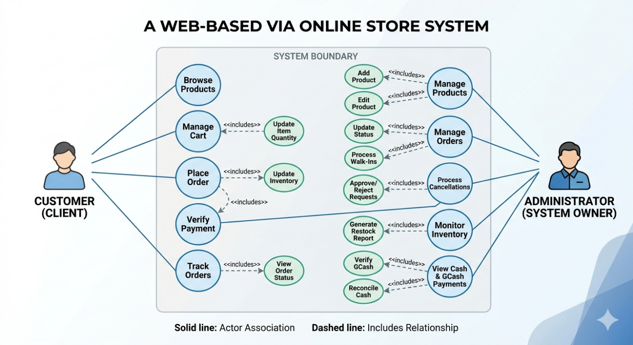

6.2 System Flowchart

Order Processing Pipeline
This pipeline manages incoming order requests, utilizing an execution flow that checks stocks and parses payload origins before modifying client cart contents.

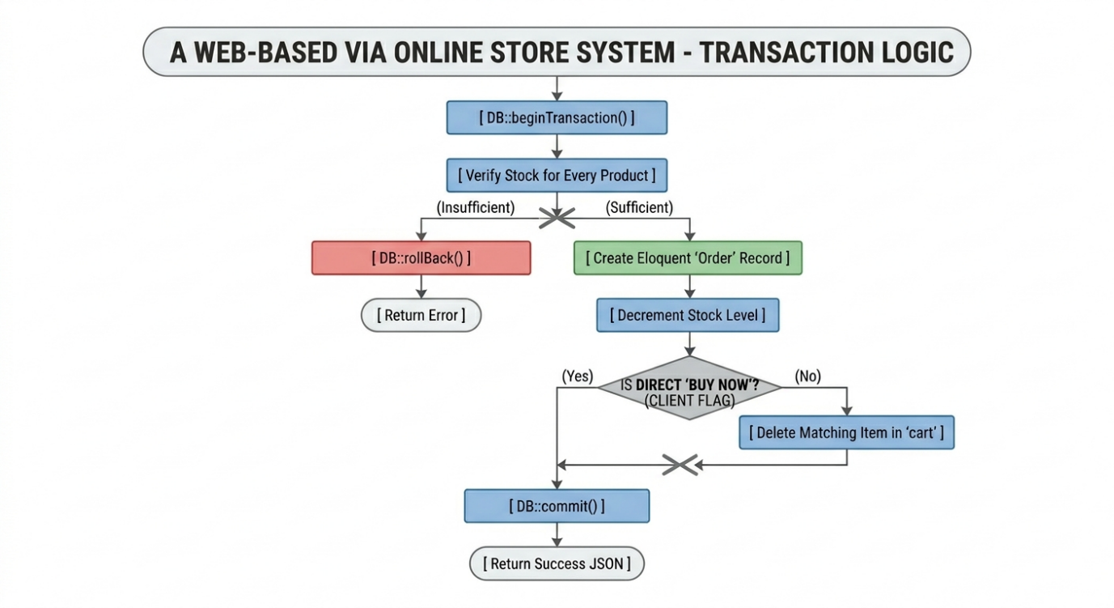

CHAPTER 7: DATABASE STRUCTURE

7.1 Relational Schema Definition
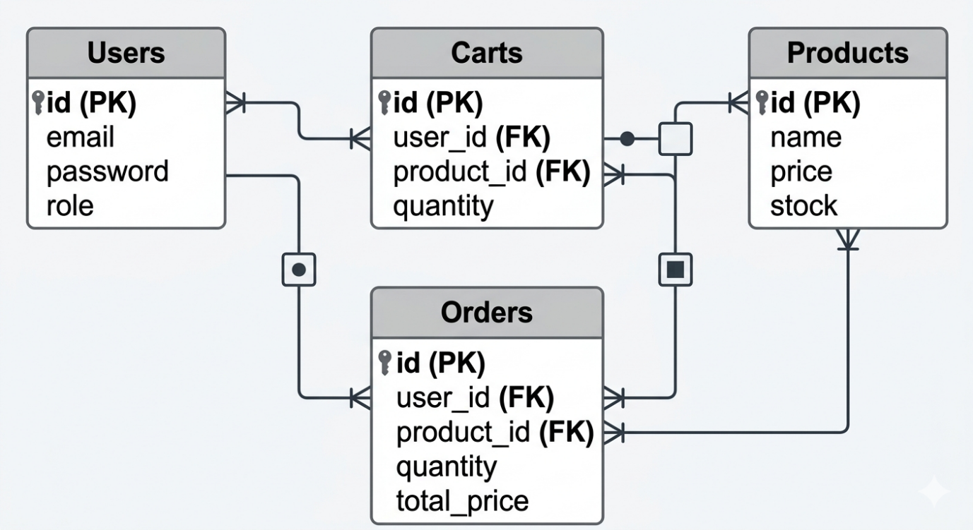

1. users Table
Stores account metadata and dynamic user tracking flags.
- id (BIGINT, Primary Key, Auto Increment)
- fullname (VARCHAR(255), Not Null)
- email (VARCHAR(255), Unique, Not Null)
- password (VARCHAR(255), Nullable - Allows standard Google OAuth bypass paths)
- role (ENUM('admin', 'customer'), Default 'customer')
- phone (VARCHAR(50), Nullable)
- location (TEXT, Nullable)
- last_seen (TIMESTAMP, Nullable)

2. products Table
Maintains baseline identity variables for clothing inventories.
- id (BIGINT, Primary Key, Auto Increment)
- name (VARCHAR(255), Not Null)
- category (VARCHAR(100), Not Null)
- price (DECIMAL(10,2), Not Null)
- stock (INT, Not Null)
- image_url (TEXT, Nullable)

3. carts Table
Preserves client selection lines inside persistent database records via Eloquent relationships.
- id (BIGINT, Primary Key, Auto Increment)
- user_id (FOREIGN KEY referencing users(id) ON DELETE CASCADE)
- product_id (FOREIGN KEY referencing products(id) ON DELETE CASCADE)
- quantity (INT, Not Null, Default 1)

4. orders Table
Captures absolute transactional fulfillment logs.
- id (BIGINT, Primary Key, Auto Increment)
- user_id (FOREIGN KEY referencing users(id) ON DELETE RESTRICT)
- product_id (FOREIGN KEY referencing products(id) ON DELETE RESTRICT)
- quantity (INT, Not Null)
- total_price (DECIMAL(10,2), Not Null)
- status (VARCHAR(50), Default 'Pending')
- created_at (TIMESTAMP)

5. expenses Table
Tracks operational costs to manage store financial visibility.
- id (BIGINT, Primary Key, Auto Increment)
- description (TEXT, Not Null)
- category (VARCHAR(100), Not Null)
- amount (DECIMAL(10,2), Not Null)
- date_added (TIMESTAMP)

CHAPTER 8: IMPLEMENTATION AND TESTING

8.1 Development Process
The building lifecycle progressed through an agile framework. Initial work focused on Laravel database migrations and model composition, spinning up tables directly inside the Aiven cloud storage layer. Core development then shifted to setting up custom Laravel middleware stacks (CheckAdmin and CheckCustomer) to intercept route files. Finally, transaction management features were integrated into the checkout controller methods using DB::transaction closures to process purchasing paths safely.

8.2 Testing Procedures
- Role Verification Tests: Asserting security limits by attempting direct access requests to administrative web paths (e.g., /admin/expenses) using clear customer account credentials to ensure automatic route blocking via middleware and execution of Laravel standard unauthorized responses (403) trigger.
- Stock Exhaustion Simulation: Simulating rapid checkout actions against low-stock items to verify that secondary controller processes hit inventory limits, fail cleanly, and execute a data DB::rollBack() state safely.
- Direct Check Payload Evaluation: Triggering request attributes configured with target parameters to ensure that immediate standalone purchases process properly via Eloquent models without clearing out user entries within the core cart tables.

8.3 Problems Encountered and Solutions Applied
- Mailer Protocol Network Failures (ENETUNREACH): Remote deployment containers occasionally failed to maintain connection streams with external mail distribution clusters. Solution: Modified the core infrastructure parameters inside Laravel’s local configuration variables, overriding transport timeouts and ensuring network paths map smoothly.
- Unintended Cart Emptying During Direct Purchases: Standard ordering routines originally cleared out the user's entire shopping cart database entries, regardless of whether a purchase originated from the shopping cart page or via an isolated "Buy Now" button action. Solution: Refactored the storage mechanics inside the checkout controller to evaluate a distinct state flag, executing the Eloquent cart clear methods only when processing a full cart collection purchase request.

CHAPTER 9: CONCLUSION

9.1 Summary of Achievements
The project successfully deployed A Web-Based Via Online Store System, implementing a dual-role architectural design on the Laravel framework. The application protects customer data workflows, tracks permanent database carts, prevents race-condition stock flaws, and gives administrators deep cost visibility by tracking store expenses directly alongside real-time sales numbers.

9.2 Benefits of the System
The platform automates store tracking updates, ensuring that stock numbers and administrative expense accounts stay accurate without manual data entry. Consumers gain a reliable shopping application where cart arrays remain stable across varying checkout methods.

9.3 Learning Gained
Building this application highlighted the critical importance of keeping database operations atomic. Utilizing Laravel's database transaction systems ensured that data updates either complete entirely or fail safely without partial errors, illustrating best practices in secure backend system engineering using modern enterprise frameworks.

CHAPTER 10: RECOMMENDATIONS

10.1 Future Improvements & Enhancements
- Live Payment Provider Integration: Migrating beyond manual status confirmation checks toward direct API integrations with authorized platforms (such as the PayMongo, Maya, or GCash developer networks) to handle instant, programmatic payment callbacks.
- Dynamic Delivery Mapping Webhooks: Integrating real-time third-party shipping logistics APIs (such as Lalamove, J&T Express, or Ninja Van) to automate delivery cost estimations based on live courier distances.
- Automated Customer Status Alerts: Implementing event listener architectures in Laravel to automatically dispatch real-time alerts to customers as soon as an administrator updates an order state from the backend dashboard.

CHAPTER 11: REFERENCES
- Laravel. (2026). Laravel Documentation: Architecture Concepts, Eloquent ORM, and Database Transactions. Retrieved from https://laravel.com
- MySQL NV. (2025). MySQL 8.0 Reference Manual: InnoDB Transaction Model and Isolation Levels. Retrieved from https://dev.mysql.com/doc/
- PHP Documentation Group. (2026). PHP Hypertext Preprocessor Language Core Manual and Object Oriented Coding Practices. Retrieved from https://www.php.net/docs.php

